REGISTRATION FORM
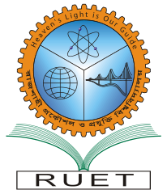
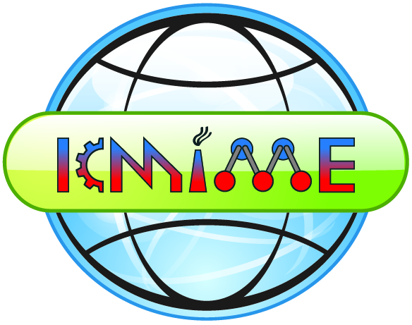
International Conference On
Mechanical, Industrial and Materials Engineering 2022
(ICMIME 2022)
20-22 December 2022, RUET, Rajshahi-6204, Bangladesh

Registration Deadline – 25th November 2022

Name  (Prof/ Dr./ Mr./ Mrs/ Ms.) |  | Last name First Name Other name (if any)
Affiliation |  | : …………………………………….........
Address |  | : …………………………………….........  ............................................................
Tel: ………………….......... |  |  | Fax: ………………….......
Cell: …………………......... |  |  | Email: ………………........
 | I plan to attend the Conference.
 | I intend to present a paper (Paper ID:____________).
 | I am a student, I intend to present my paper (Paper ID:____________).
I have paid the Registration fee by : Online banking/TT/pay order/Draft (in favor of ‘Chairman, ICMIME, Faculty of ME, RUET:
- A/C No. 10231, Rupali Bank, RUET Branch, Rajshahi-6204, Bangladesh. SWIFT code: RUPBBDDH.

- A/C No. 36150, Islami Bank Bangladesh Ltd, Rajshahi Branch, Rajshahi, Bangladesh. SWIFT code: IBBLBDDH

 | Amount: i) USD 300 ii) USD 200 iii) BDT 6000 iv) BDT 2000 v) BDT 3000
(Signature & Date)

